# 

#### Game Design Document

#### “A simple adventure game with RPG flavor”

###### IGN: A Castlevania ripoff

Bekho Team: Stop copying our games!

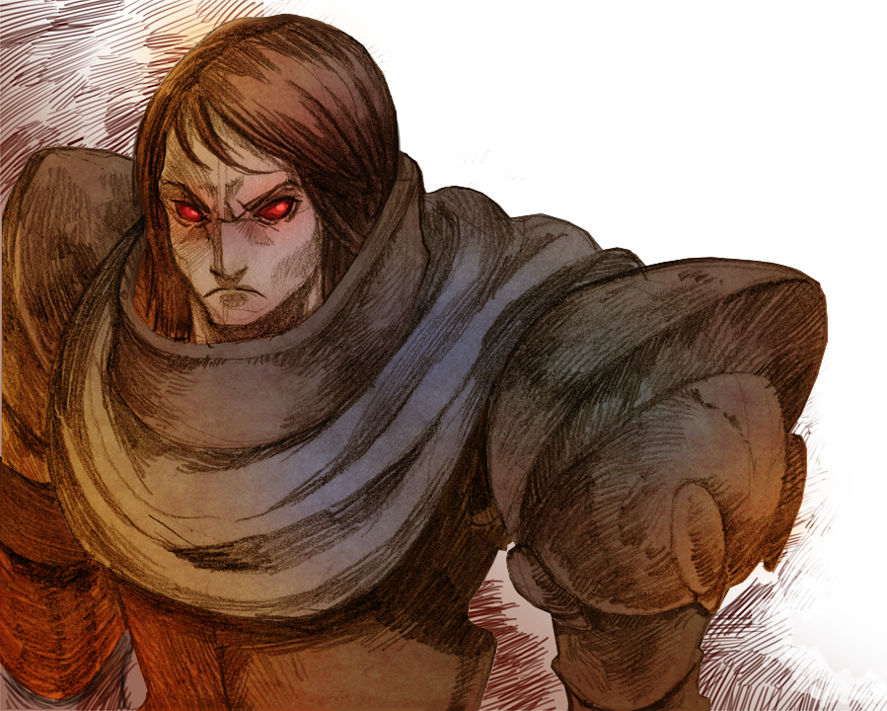

## Summary

Summary

Revisions

Story

Game Mechanics

Combat system

World’s Navigation

World’s Locations

Sanctuary town

Oblivion’s Forest

Stone-man’s Island

Volcano Highlands

Land of the fallen angels

The Hero

Weapons

Shields

Armors

Boots

Rings

Potions

Skills

Hero’s stats

Stats Equations

Game’s damage equations

Bestiary

Bat

Reaper

Eye’s ghost

Reaper Liutenant

Sanctuary Demonic lord Level 1

Caterpillar

Plant

Werewolf

Elf archer

Elf warrior

Big Werewolf

Green darkness

Raven

Electric Cloud

Thief with knife

Ghost pirate

Ghost Pirate’s Captain

Kraken

Demon Bee

Imp

Fire skull

Red Knight

Lava Golem

Magma Phoenix

Beholder

Cursed soul

Warlock

Executioner

Impaler

Aurora, Hero’s wife

Fallen Angel’s Demonic lord Level 1

Fallen Angel’s Demonic lord Level 2

Fallen Angel’s Demonic lord Level 3

NPCs

Thiltran the abbot

Kathia Steel

Nessa Faelivrin

The Blacksmiths

The Swordsmen

The Wizards

The Annoying Quest Givers

Game’s timeline

Main Campaign

Quests drafts

Quests Descriptions

Quest 1

Quest 2

Quest 3

Quest 4

Quest 5

Quest 6

Quest 7

Quest 8

Quest 9

Quest 10

Quest 11

Quest 12

Quest 13

Quest 14

Quest 15

Quest 16

Quest 17

Quest 18

Quest 19

Quest 20

Quest 21

Quest 22

Quest 23

Quest 24

Quest 25

Quest 26

Quest 27

Quest 28

Quest 29

Quest 30

Quest 31

Gui Elements

Gui flow

Micro Transactions

Assets Integration

References

Battle Scenes references:

Inventory reference

Roadmap

## 

## 

## 

## 

## 

## Revisions

|  |  |  |
| --- | --- | --- |
| 31/12/2011 | Israel Lazo | Initial Soul Avenger GDD |
| 13/01/2012 | Vicente Conejeros | Added a lot more descriptions about the game |
| 17/01/2012 | Sebastián Franchini | Added some visual references and list of remaining demo assets |
| 24/01/2012 | Vicente Conejeros | Added the first 5 quests |
| 06/02/2012 | Jonathan Monroy | Added initial gui flow description |
| 10/02/2012 | Vicente Conejeros | Added initial bestiary and moved damage explanation to be below the stat explanation for quick reference |
| 15/02/2012 | Vicente Conejeros | Added battle timeline |
| 08/03/2012 | Vicente Conejeros | Added all items, an enemies description ordered by quests |
| 19/03/2012 | Jonathan Monroy | Added description to items 75% completed |
| 16/5/2012 | Arturo | Added final descriptions of 100% of items |

## 

## 

## 

## 

## 

## Story

In a world where darkness reigned for more than a thousand years, there is a warrior, Sigmus. He, for many years was the Demonic Lord’s right hand, who with his great evil and minions rules every land. But after knowing his love and open his eyes to his real mission, Sigmus leave the Demonic Lord to fight against him as a Soul Avenger.

Sigmus is in-mortal, due to a gift given by the Demonic Lord, whose magic allows to this warrior to live every year were his anger fill his hearth.

After 300 years of murdering and destroying in the name of the Demonic Lord, one day, Sigmus was sent to the region called Elfic Haze. In the middle of the destruction, he murdered an entire family, and while doing his task burning the house of the family he heard a groan. He follow the screams and found a baby... and for the first time in his life he was unable to kill. This is the birth of the story of Soul Avenger

## 

## 

## 

## 

## 

## 

## 

## 

## 

## Game Mechanics

La mecánica estará muy influenciada por la facilidad de jugar en dispositivos móviles, con controles sencillos e interacción no-intensiva de parte del usuario.

### 

### Combat system

The game’s combat system is semi automatic. If a enemy exists it means the hero will try to kill it. The role of the player during the combat is

* Select the hero’s target(changing the current one)
* Replace the hero’s weapons, armor or shields
* Use the hero’s special skills or drink a potion

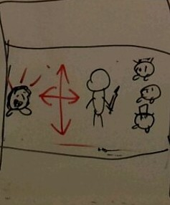

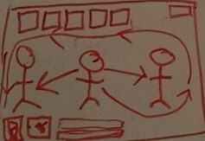

#### 

### 

### 

### 

### 

### 

### 

### World’s Navigation

#### The whole world is an island where 4 towns can be unlocked(the first one is already unlocked)

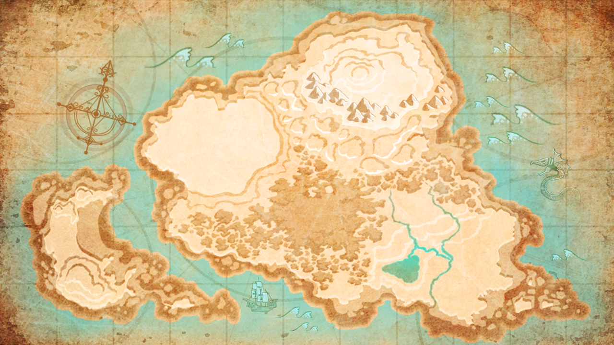

#### Each town has its own theme, also each one has the following items/places:

* Armory(weapons)
* Armory(shields)
* Magic shop(potions and magic items)
* Castle(main quests)
* Special quest icon



## World’s Locations

### Sanctuary town

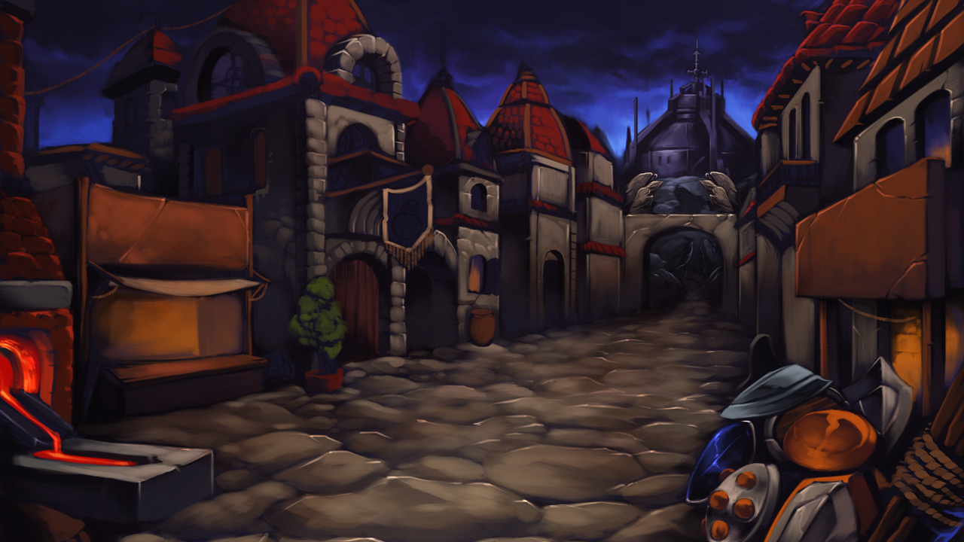

A classical medieval town. With a castle in the background and a market in the center of the town

### Oblivion’s Forest

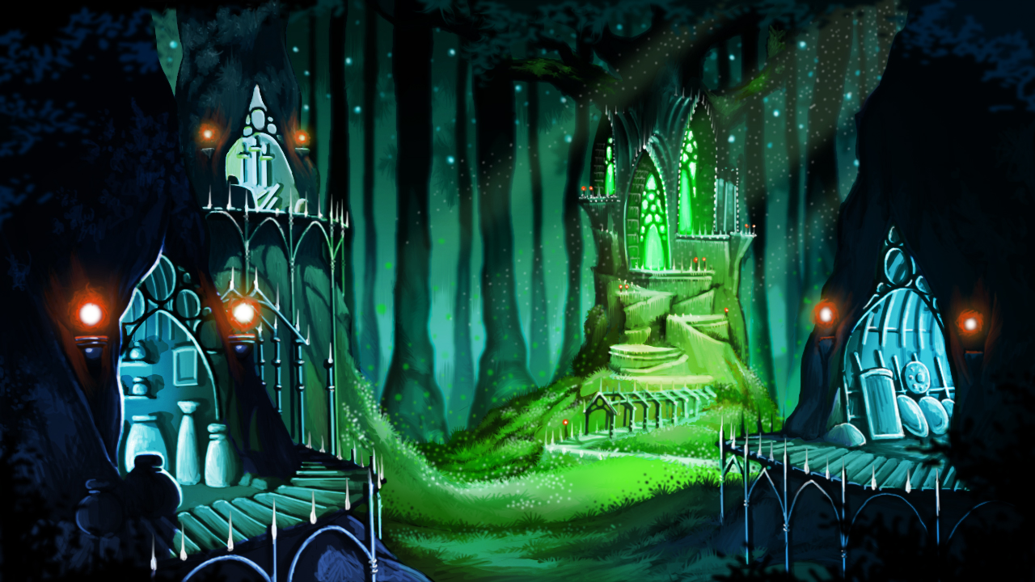

A town in the middle of a big forest. With a big tree in the background surrounded by a market

### 

### Stone-man’s Island

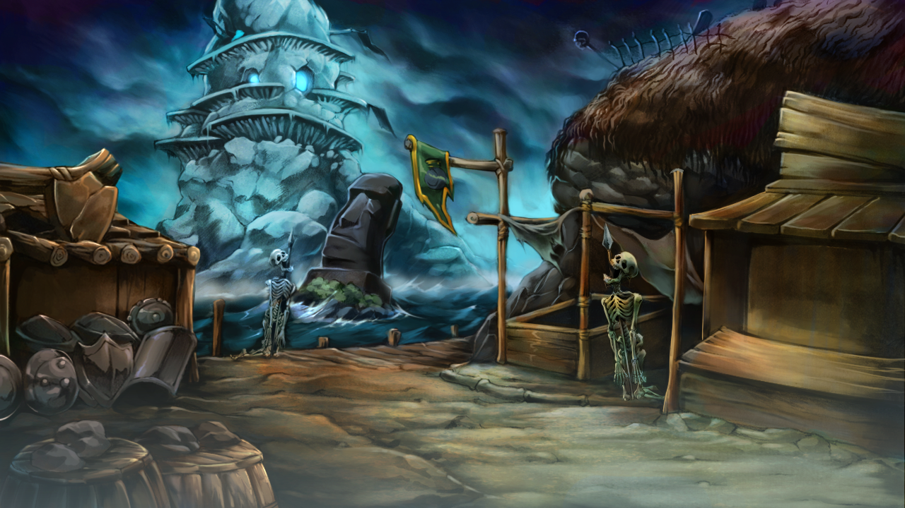

The Seaport city of the Stone-man’s Island has the town in near the shore. One of the important props this island has is a small moai head

### Volcano Highlands

A town surrounding a volcano. the market is in the middle of the town. the peak’s road can be seen on the background of the town

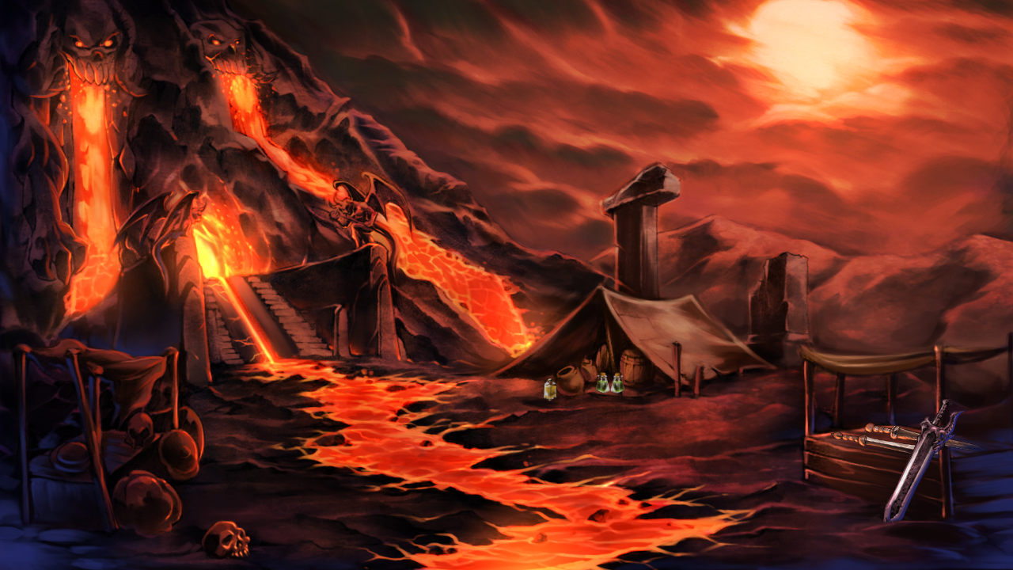

### 

### Land of the fallen angels

A compound of flying islands where an ancient holy war took place

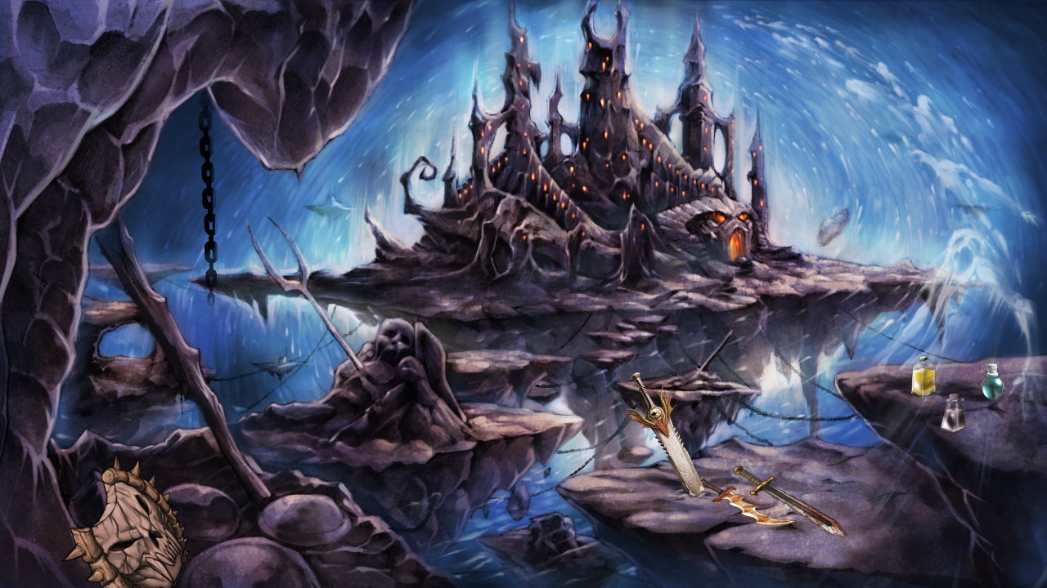

## 

## 

## 

## 

## 

## 

## 

## 

## The Hero

The hero is a classic knight with the difference that his main purpose is taking vengeance for his lost soul.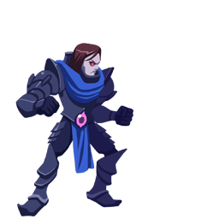



##### 

### 

### 

### 

### 

### 

### 

### 

### 

### Weapons

the following is the list of weapons of the game

|  |  |  |  |  |  |  |  |  |  |
| --- | --- | --- | --- | --- | --- | --- | --- | --- | --- |
|  | |  |  | | --- | --- | | name | adept's sword | | description | A basic sword, specially crafted for being used by new warriors. | | stats | bdmg:4 | | price | 500 coins | |
|  | |  |  | | --- | --- | | name | acolyte's sword | | description | Old weapon belonging to a priest who claimed to have direct contact with the heavenly father of the Luminous Guardians. | | damage | bdmg:6 | | price | 2900 coins | |
|  | |  |  | | --- | --- | | name | templar's sword | | description | This sword passed from hand to hand by the most courageous captains of the sanctuary’s defense forces. | | damage | bdmg:15 | | price | 5400 coins | |
|  | |  |  | | --- | --- | | name | blessed sword | | description | It is said this sword was blessed by one of the ancient warriors of light. | | damage | bdmg: 50 | | price | 2 gems | |
|  | |  |  | | --- | --- | | name | sentinel's sword | | description | The forest’s sentinels use these when encountering spies in the woods. | | damage | 40 | | price | 0 | |
|  | |  |  | | --- | --- | | name | ranger's sword | | description | When the rangers have no arrows left in their quivers, they’ll unsheathe their sharp swords. | | damage | 55 | | price | 0 | |
|  | |  |  | | --- | --- | | name | forest sages' sword | | description | This sword is only forged for those who decide to protect the forests with their lives. | | damage | 70 | | price | 0 | |
|  | |  |  | | --- | --- | | name | life tree sword | | description | Sword whose blade was polished with the great tree of life, being the only known sword that can cut any tree in half in one pass. | | damage | 75 | | price | 0 | |
|  | |  |  | | --- | --- | | name | seaman's sword | | description | A rather common sword used by the fishermen of the area. | | damage | 80 | | price | 0 | |
|  | |  |  | | --- | --- | | name | quartermaster's sword | | description | When you’re in charge of the ship, you need a sword like this to show your rank. | | damage | 10 | | price | 0 | |
|  | |  |  | | --- | --- | | name | buccaneer's sword | | description | Pirates used these to submit their enemies. The ghosts still carry them. | | damage | 10 | | price | 0 | |
|  | |  |  | | --- | --- | | name | captain's sword | | description | The pirate captain always used this sword. Even after death it is his weapon of choice. | | damage | 10 | | price | 0 | |
|  | |  |  | | --- | --- | | name | forged sword | | description | This sword’s been reforged three with the molten lava from the volcano. | | damage | 10 | | price | 0 | |
|  | |  |  | | --- | --- | | name | mythril sword | | description | Forged with the hardest metal known, mythril, by ancient elves who lived near the volcano. | | damage | 10 | | price | 0 | |
|  | |  |  | | --- | --- | | name | volcanic sword | | description | Only true blacksmiths dare enter the volcano to forge swords like these. It’s almost as hard as diamond. | | damage | 10 | | price | 0 | |
|  | |  |  | | --- | --- | | name | dragon's sword | | description | Its huge power comes from the dragon scales used to forge it. | | damage | 10 | | price | 0 | |
|  | |  |  | | --- | --- | | name | ethereal sword | | description | This sword is made of metals taken from old graves. | | damage | 10 | | price | 0 | |
|  | |  |  | | --- | --- | | name | spirit's sword | | description | The blacksmith who created it had it impregnated with phoenix’s tears. | | damage | 10 | | price | 0 | |
|  | |  |  | | --- | --- | | name | damned sword | | description | This sword was used in ritualistic human sacrifices for centuries. | | damage | 10 | | price | 0 | |
|  | |  |  | | --- | --- | | name | demonic sword | | description | It’s blade is a polished bone from a cursed dragon. Can slice through every living creature. | | damage | 10 | | price | 0 | |
|  | |  |  | | --- | --- | | name | holy sword | | description | Hidden by the first warriors of light after its creation, the destruction power of this sword scares even its creators. | | damage | 10 | | price | 0 | |

### Shields

|  |  |  |  |  |  |  |  |  |  |
| --- | --- | --- | --- | --- | --- | --- | --- | --- | --- |
|  | |  |  | | --- | --- | | name | adept's shield | | description | A basic shield, specially crafted for the new warriors. | | defense | fixed: 2 | | price | 800 coins | |
|  | |  |  | | --- | --- | | name | templar's shield | | description | This shield has passed for generations of the sanctuary’s high templars. | | defense | fixed: 8 | | price | 0 | |
|  | |  |  | | --- | --- | | name | sentinel's shield | | description | The sentinels from Oblivion Forest use them to hide themselves in the woods’ foliage. | | defense | 10 | | price | 0 | |
|  | |  |  | | --- | --- | | name | seaman's shield | | description | This shield was used for the islanders to fight the pirate ghosts decades ago. | | defense | 10 | | price | 0 | |
|  | |  |  | | --- | --- | | name | forged shield | | description | The smiths used hardened oak wood and bronze planks to make this shield. | | defense | 10 | | price | 0 | |
|  | |  |  | | --- | --- | | name | ethereal shield | | description | This shield’s skull comes from a legendary graveyard placed in the edge of the world. | | defense | 10 | | price | 0 | |
|  | |  |  | | --- | --- | | name | forest sages' shield | | description | The elven elders protected their beloved forest for decades with these hard shields. | | defense | 10 | | price | 0 | |
|  | |  |  | | --- | --- | | name | buccaneer's shield | | description | It can bind and absorb the corpses’ souls without effort. | | defense | 10 | | price | 0 | |
|  | |  |  | | --- | --- | | name | volcanic shield | | description | The chains glow with a malevolent light, as a pyre’s ashes. | | defense | 10 | | price | 0 | |
|  | |  |  | | --- | --- | | name | damned shield | | description | This ancient shield was forged by unknown blacksmiths in the demonic forges of the underworld. | | defense | 10 | | price | 0 | |
|  | |  |  | | --- | --- | | name | holy shield | | description | Created in secret, this shield provides the strongest defense against the dark forces of the Demoniac Lord. | | defense | 10 | | price | 0 | |

### 

### Armors

|  |  |  |  |  |  |  |  |  |  |
| --- | --- | --- | --- | --- | --- | --- | --- | --- | --- |
|  | |  |  | | --- | --- | | name | adept's armor | | description | A basic armor, specially crafted for being used by new warriors. | | defense | fixed: 4 | | price | 900 coins | |
|  | |  |  | | --- | --- | | name | acolyte armor | | description | Old armor belonging to a priest who claimed to have direct contact with the heavenly father of the Luminous Guardians. | | defense | fixed: 7 | | price | 2500 coins | |
|  | |  |  | | --- | --- | | name | blessed armor | | description | This ancient armor is one of the Sanctuary’s biggest jewels, protected by the city sages. | | defense | fixed: 40, 5% | | price | 4 gems | |
|  | |  |  | | --- | --- | | name | sentinel's armor | | description | Armor worn by the sentinels of Oblivion Forest. Light as a cloak. | | defense | 10 | | price | 0 | |
|  | |  |  | | --- | --- | | name | ranger's armor | | description | This armor can take several arrows without letting the wearer get hurt. | | defense | 10 | | price | 0 | |
|  | |  |  | | --- | --- | | name | forest sages' armor | | description | The forest elven have worn these light weigthed armors under their capes since they can remember. | | defense | 10 | | price | 0 | |
|  | |  |  | | --- | --- | | name | seaman's armor | | description | This armor can save your life at the sea, with its hidden airpockets. | | defense | 10 | | price | 0 | |
|  | |  |  | | --- | --- | | name | quartermaster's armor | | description | Heavier than other armors, this will boost your defence with its steel scales. | | defense | 10 | | price | 0 | |
|  | |  |  | | --- | --- | | name | buccaneer's armor | | description | If you are going for the almighty Kraken, you’ll probably want one of these, made from a strong iron alloy. | | defense | 10 | | price | 0 | |
|  | |  |  | | --- | --- | | name | forged armor | | description | This armor is reinforced with several layers of alloyed copper, taken from the volcano’s border. | | defense | 10 | | price | 0 | |
|  | |  |  | | --- | --- | | name | mythril armor | | description | Mythril rocks have to be mined inside the volcano, making these armors highly valuable. | | defense | 10 | | price | 0 | |
|  | |  |  | | --- | --- | | name | volcanic armor | | description | It shines with the incandescent bright of the molten lava. | | defense | 10 | | price | 0 | |
|  | |  |  | | --- | --- | | name | ethereal armor | | description | The metal it’s made of remained a secret for centuries. Now we know it comes from a huge meteor. | | defense | 10 | | price | 0 | |
|  | |  |  | | --- | --- | | name | spirit's armor | | description | This armor can protect your body from the fallen angels’ souls. | | defense | 10 | | price | 0 | |
|  | |  |  | | --- | --- | | name | damned armor | | description | It is said that the skulls can recognize good from evil. | | defense | 10 | | price | 0 | |
|  | |  |  | | --- | --- | | name | holy armor | | description | Assembled by the strongest light warriors, this armor has deep effects on the defense of the warrior who tries to wear it. | | defense | 10 | | price | 0 | |

### Boots

|  |  |  |  |  |  |  |  |  |  |
| --- | --- | --- | --- | --- | --- | --- | --- | --- | --- |
|  | |  |  | | --- | --- | | name | adept's boots | | description | The first item you get when you become an adept are these boots, made from bear fur. | | defense | fixed: 2 | | price | 400 coins | |
|  | |  |  | | --- | --- | | name | acolyte boots | | description | These boots are covered in aluminium, making them mildly resistant. | | defense | fixed: 4 | | price | 2100 coins | |
|  | |  |  | | --- | --- | | name | blessed boots | | description | The golden wings on these boots are usually submerged in holy water for weeks. | | defense | fixed: 20 | | price | 1 gem | |
|  | |  |  | | --- | --- | | name | sentinel's boots | | description | These boots have always been worn by the swift elven. | | defense | 10 | | price | 0 | |
|  | |  |  | | --- | --- | | name | ranger's boots | | description | The forest rangers protect Oblivion from the monsters shooting arrows as they run wearing these. | | defense | 10 | | price | 0 | |
|  | |  |  | | --- | --- | | name | forest sages' boots | | description | The bronze wings will give you a slight speed boost for your fights. | | defense | 10 | | price | 0 | |
|  | |  |  | | --- | --- | | name | seaman's boots | | description | They are made with the eerie raven’s fur. | | defense | 10 | | price | 0 | |
|  | |  |  | | --- | --- | | name | quartermaster's boots | | description | These boots were found on a shrine, in a far island lost in the ocean. | | defense | 10 | | price | 0 | |
|  | |  |  | | --- | --- | | name | buccaneer's boots | | description | Found under the sea, inside the ruins of a sunken ship. | | defense | 10 | | price | 0 | |
|  | |  |  | | --- | --- | | name | forged boots | | description | The elders tell stories about warriors who wore them to beat the fire imps. | | defense | 10 | | price | 0 | |
|  | |  |  | | --- | --- | | name | mythril boots | | description | The mythril in these boots provide an outstanding amount of extra defense. | | defense | 10 | | price | 0 | |
|  | |  |  | | --- | --- | | name | volcanic boots | | description | These boots let you walk through lava for short periods of time. | | defense | 10 | | price | 0 | |
|  | |  |  | | --- | --- | | name | ethereal boots | | description | It’s stitched with the purest silk string available in the world. | | defense | 10 | | price | 0 | |
|  | |  |  | | --- | --- | | name | spirit's boots | | description | The smith who made them used the bones of a deceased warrior, whose spirit still revolves around them. | | defense | 10 | | price | 0 | |
|  | |  |  | | --- | --- | | name | damned boots | | description | Made in the demon’s forge by imp blacksmiths, and brought to this land by a valiant warrior. | | defense | 10 | | price | 0 | |
|  | |  |  | | --- | --- | | name | holy boots | | description | Of uncertain origin, this boots gives great advantages to the light warriors on the battlefield. | | defense | 10 | | price | 0 | |

### Rings

|  |  |  |  |  |  |  |  |  |  |
| --- | --- | --- | --- | --- | --- | --- | --- | --- | --- |
|  | |  |  | | --- | --- | | name | blessed ring | | description | Blessed by the sanctuary priests, it will provide a helpful health bonus. | | buffs | health:+10 | | price | 1 gem | |
|  | |  |  | | --- | --- | | name | bravery ring | | description | Only the bravest warriors are rewarded with this ring that boosts their strength. It’s made from a silver and titan’s blood alloy. | | buffs | str: +20 | | price | 400 coins | |
|  | |  |  | | --- | --- | | name | ring of Apollo | | description | A warrior called Apollo wore it centuries ago. It is said he was the fastest and swiftest captain in the armies of light. | | buffs | 10 | | price | 0 | |
|  | |  |  | | --- | --- | | name | ring of the sages | | description | This gold ring is filled with little agates polished by the temple sages. | | buffs | 10 | | price | 0 | |
|  | |  |  | | --- | --- | | name | ring of blood | | description | The first demonic lord submerged this ring in his own blood to increase his health. | | buffs | 10 | | price | 0 | |
|  | |  |  | | --- | --- | | name | ring of gaia | | description | It contains the power of the earth. It will give the wearer a bigger chance to get critical strikes. | | buffs | 10 | | price | 0 | |
|  | |  |  | | --- | --- | | name | lightning ring | | description | The metal of this ring was mined from the top of a huge mountain that was repeatedly struck by a hundred lightnings. | | buffs | 10 | | price | 0 | |
|  | |  |  | | --- | --- | | name | tangata manu's ring | | description | This ring guided the first islanders through the oceans when they escaped from the volcano’s eruption. | | buffs | 10 | | price | 0 | |
|  | |  |  | | --- | --- | | name | ring of titans | | description | When the titans were sealed in their underwater prisons, this ring was the only thing left on the surface. | | buffs | 10 | | price | 0 | |
|  | |  |  | | --- | --- | | name | diamond ring | | description | Crafted by the best artisans. This ring has the particularity of improving the chance to do critical hits while attacking. | | buffs | 10 | | price | 0 | |
|  | |  |  | | --- | --- | | name | abyss ring | | description | This ring’s amethist was found at the bottom of a rocky abyss. it is said it increases the agility. | | buffs | 10 | | price | 0 | |
|  | |  |  | | --- | --- | | name | ring of destiny | | description | It was found inside the biggest pine in the forest, a millennial tree that’s the forest shrine. | | buffs | 10 | | price | 0 | |
|  | |  |  | | --- | --- | | name | ring of doom | | description | The ghosts of the lost lands like to forge these beautiful engraved rings. | | buffs | 10 | | price | 0 | |
|  | |  |  | | --- | --- | | name | ring of vengeance | | description | This ring is covered with the blood of an innocent warrior who was killed by the hands of the Demoniac Lord. | | buffs | 10 | | price | 0 | |
|  | |  |  | | --- | --- | | name | holy ring | | description | The stones of this ring came from the sky in an ancient era, according to the elders. | | buffs | 10 | | price | 0 | |

### 

### 

### 

### 

### 

### 

### 

### 

### Potions

|  |  |  |  |  |  |  |  |  |  |
| --- | --- | --- | --- | --- | --- | --- | --- | --- | --- |
|  | |  |  | | --- | --- | | name | Healing Potion | | description | A life restoring potion. Tastes like raspberries and deer’s blood. | | buffs | HLT:+25% | | price | 75 | |
|  | |  |  | | --- | --- | | name | Magic Potion | | description | A magic restoring potion. Made with water from the source. | | buffs | MAG:+25% | | price | 75 | |
|  | |  |  | | --- | --- | | name | Berserk Potion | | description | This Potion will increase your damage by sacrificing your defense. It’s made with titan’s sweat, people say. | | buffs | TotalDamage: +50%  BaseDef: -40%  Duration: 15 seconds | | price | 200 | |
|  | |  |  | | --- | --- | | name | Iron Skin Potion | | description | This Potion doubles your defense for a certain amount of time. One of its ingredients is turtle shell. | | buffs | BaseDef: +100%  Duration: 15 seconds | | price | 200 | |
|  | |  |  | | --- | --- | | name | Lucky Shot Potion | | description | Critical hit rate is increased for a certain amount of time. It comes inside the fallen stars. | | buffs | Crit:+50%  Duration: 30 seconds | | price | 350 | |
|  | |  |  | | --- | --- | | name | Potion of Hermes | | description | This special potion increases the movement speed for a certain amount of time. Even better than a rabbit’s foot. | | buffs | Agility: +50%  Duration: 30 seconds | | price | 350 | |
|  | |  |  | | --- | --- | | name | Phoenix Tears | | description | The myth says this potion can fool the death. Actually it will save you from death, allowing you to continue fighting. | | buffs | Reincarnation | | price | 1000 | |
|  | |  |  | | --- | --- | | name | Elixir | | description | This Potion restores full Health and Magic. It’s not really tasty, but it can save your life. | | buffs | +100%HP, +100%MP | | price | 500 | |

### Skills

### 

|  |  |  |  |  |  |  |  |
| --- | --- | --- | --- | --- | --- | --- | --- |
|  | d   |  |  | | --- | --- | | name | Slash | | description | High damaging single blow | | buffs | DMG: 50 + STR_Px10; | |
|  | |  |  | | --- | --- | | name | Shield | | description | A protective shield against the attacks of enemies | | buffs | DEF: STR_Px3 + 50%  TIME: 20s | |
|  | d   |  |  | | --- | --- | | name | Curse | | description | When attacking the player, the enemies harm themselves | | buffs | DMG: 25%  TIME: 10s | |
|  | |  |  | | --- | --- | | name | Slow motion | | description | Slows down the enemies during a limited time | | buffs | TIME: 10s | |
|  | |  |  | | --- | --- | | name | charge | | description | Charge up against the enemies in straight line | | buffs | DMG: 70 + STR_Px10 | |
|  | |  |  | | --- | --- | | name | thunder | | description | High damage spell to target enemy | | buffs |  | |
|  | |  |  | | --- | --- | | name | drain life | | description | Steals the life of the enemies | | buffs |  | |
|  | |  |  | | --- | --- | | name | meteor | | description | Summon a wave of falling meteors from the sky | | buffs |  | |
|  | |  |  | | --- | --- | | name | summon dragon | | description | Summons a dragon that damages all enemies | | buffs |  | |
|  | |  |  | | --- | --- | | name | soul avenger | | description | Increases all stats during a certain amount of time | | buffs |  | |

### 

### 

### 

### Hero’s stats

* Level
* Experience
* Primary stats
  + Health
  + Magic
  + Strength
  + Agility
* Secondary stats
  + Critical hit probability

Each level is obtained by gaining experience points the amount of experience points needed to pass to the next level is performed by the following equation

$P{}_{i+1}=1000 ⋅\left[P_{i}+C\left(P_{i},2\right)\right]$

this equation was taken from

<http://www.monkeysushi.net/gaming/DnD/math.html#xp>

where

$P_{1 }=0$

$P_{2}=1000$

so for example the progress for the first 5 levels is

|  |  |
| --- | --- |
| Level | Exp points |
| 1 | 0 |
| 2 | 1000 |
| 3 | 3000 |
| 4 | 6000 |
| 5 | 10000 |

the maximum level(cap) is 30, experience can still be gained but there is no reward in that

### Stats Equations

|  |  |
| --- | --- |
| Health | $Max Health=(350 + 30⋅\left(HltLvl-1\right))Hlt\%Buf+HltFxBuf$ |
| Magic | $Max Magic=(100+10⋅\left(MagLvl -1\right))Mag\%Buf+ MagFxBuf$ |
| Critical | $Critical = 0.05 + 0<Buffs < 0.5$ |

So for example

|  |  |  |
| --- | --- | --- |
| Level 0 No Buffs | Level 15 No Buffs | Level 30 No Buffs |
| |  |  | | --- | --- | | Health |  | | Mana |  | | Strength |  | | Agility |  | | Critical |  | | |  |  | | --- | --- | | Health |  | | Mana |  | | Strength |  | | Agility |  | | Critical |  | | |  |  | | --- | --- | | Health |  | | Mana |  | | Strength |  | | Agility |  | | Critical | $5\%$ | |

## 

## Game’s damage equations

Melee Attack damage is calculated with the following equation



where

$Crt = Critical Hit$

$\%=Damage absorved$

$Fx = Fixed ammount of damage absorved$

$MxD = Maximum Damage the Attack can do$

$MnMxD = Value between the Minimum and Maximum Damage of the Attack$

$WpD= Weapon's Damage$

$Str= Strength$

$StrMx= Max Strength of the Character at the max level cap without the buffs$

Ranged Attacks are calculated as follow

## Bestiary

### Bat

|  |  |  |  |  |  |  |  |  |  |  |  |
| --- | --- | --- | --- | --- | --- | --- | --- | --- | --- | --- | --- |
|  | |  |  | | --- | --- | | Town | Sanctuary | | Type | Basic | | Xp Award | 50 | | Health | 50 | | Melee | Dmg:8-10,Recharge:0.35 | |

### Reaper

|  |  |  |  |  |  |  |  |  |  |  |  |
| --- | --- | --- | --- | --- | --- | --- | --- | --- | --- | --- | --- |
|  | |  |  | | --- | --- | | Town | Sanctuary | | Type | Basic | | Xp Award | 100 | | Health | 100 | | Melee | Dmg:10-13,Recharge:0.5 | |

### Eye’s ghost

|  |  |  |  |  |  |  |  |  |  |  |  |
| --- | --- | --- | --- | --- | --- | --- | --- | --- | --- | --- | --- |
|  | |  |  | | --- | --- | | Town | Sanctuary | | Type | Medium | | Xp Award | 150 | | Health | 180 | | Melee | Dmg:15-20,Recharge:1 | |

### 

### 

### Reaper Lieutenant

|  |  |  |  |  |  |  |  |  |  |  |  |  |  |  |  |
| --- | --- | --- | --- | --- | --- | --- | --- | --- | --- | --- | --- | --- | --- | --- | --- |
|  | |  |  | | --- | --- | | Town | Sanctuary | | Type | Mid-Boss | | Health | 1100 | | Xp Award | 350 | | Melee | Dmg:45-55,Recharge:1.5 | | Summon | Reaper,Eye_Ghost,Bat: 2,Recharge:25 | | Ranged | Dmg:35-40, Distance: 0-5, Recharge:8 | |

### Sanctuary Demonic lord Level 1

|  |  |  |  |  |  |  |  |  |  |  |  |  |  |
| --- | --- | --- | --- | --- | --- | --- | --- | --- | --- | --- | --- | --- | --- |
|  | |  |  | | --- | --- | | Town | Sanctuary | | Type | Boss | | Health | 1500 | | Xp Award | 800 | | Melee | Dmg: 50-65, Recharge: 0.5 | | Healing | Full Life, 3 times | |

### Caterpillar

|  |  |  |  |  |  |  |  |  |  |  |  |
| --- | --- | --- | --- | --- | --- | --- | --- | --- | --- | --- | --- |
|  | |  |  | | --- | --- | | Town | Forest | | Type | Basic | | Health | 200 | | Xp Award | 200 | | Melee | Dmg:25-35,Recharge:0.75 | |

### 

### 

### 

### Plant

|  |  |  |  |  |  |  |  |  |  |  |  |
| --- | --- | --- | --- | --- | --- | --- | --- | --- | --- | --- | --- |
|  | |  |  | | --- | --- | | Town | Forest | | Type | Basic | | Health | 250 | | Xp Award | 260 | | Turret | Dst:2, Dmg:37-40,Recharge:1 | |

### 

### Werewolf

|  |  |  |  |  |  |  |  |  |  |  |  |
| --- | --- | --- | --- | --- | --- | --- | --- | --- | --- | --- | --- |
|  | |  |  | | --- | --- | | Town | Forest | | Type | Medium | | Health | 280 | | Xp Award | 300 | | Melee | Dmg:40-45,Recharge:0.3 | |

### Big Werewolf

|  |  |  |  |  |  |  |  |  |  |  |  |  |  |  |  |
| --- | --- | --- | --- | --- | --- | --- | --- | --- | --- | --- | --- | --- | --- | --- | --- |
|  | |  |  | | --- | --- | | Town | Forest | | Type | Mid-Boss | | Health | 2100 | | Xp award | 1100 | | Melee | Dmg:55-65,Recharge:0.3 | | Summon | Werewolf:1, Recharge:10 | | Chargeup | Dmg:95-115,Recharge:10 | |

### 

### 

### Dark Elf archer

|  |  |  |  |  |  |  |  |  |  |  |  |
| --- | --- | --- | --- | --- | --- | --- | --- | --- | --- | --- | --- |
|  | |  |  | | --- | --- | | Town | Forest | | Type | Medium | | Health | 300 | | Xp award | 320 | | Ranged | Dmg:40-47,Recharge:1 | |

### Green darkness

|  |  |  |  |  |  |  |  |  |  |  |  |  |  |  |  |
| --- | --- | --- | --- | --- | --- | --- | --- | --- | --- | --- | --- | --- | --- | --- | --- |
|  | |  |  | | --- | --- | | Town | Forest | | Type | Boss | | Health | 3000 | | Xp Award | 2000 | | Melee | Dmg:60-80,Recharge:0.25 | | Summon | Elf Archer, Werewolf:2,Recharge:5 | | SpikeRow | Dmg:60-80 x Hit, Recharge:7 | |

### Dark Elf warrior

|  |  |  |  |  |  |  |  |  |  |  |  |
| --- | --- | --- | --- | --- | --- | --- | --- | --- | --- | --- | --- |
|  | |  |  | | --- | --- | | Town | Forest | | Type | Medium | | Health | 450 | | Xp Award | 350 | | Melee | Dmg:50-60,Recharge:0.5 | |

### 

### 

### 

### 

### Raven

|  |  |  |  |  |  |  |  |  |  |  |  |
| --- | --- | --- | --- | --- | --- | --- | --- | --- | --- | --- | --- |
|  | |  |  | | --- | --- | | Town | Island | | Type | Basic | | Health | 350 | | Xp Award | 300 | | Melee | Dmg:45-55,Recharge:1 | |

### Dark Electric Cloud

|  |  |  |  |  |  |  |  |  |  |  |  |
| --- | --- | --- | --- | --- | --- | --- | --- | --- | --- | --- | --- |
|  | |  |  | | --- | --- | | Town | Island | | Type | Basic | | Health | 500 | | Xp Award | 450 | | Melee | Dmg: 60-75,Rechage:0.5 | |

### Ghost pirate

|  |  |  |  |  |  |  |  |  |  |  |  |
| --- | --- | --- | --- | --- | --- | --- | --- | --- | --- | --- | --- |
|  | |  |  | | --- | --- | | Town | Island | | Type | Medium | | Health | 750 | | Xp Award | 550 | | Melee | Dmg: 77-85,Rechage:0.75 | |

### 

### 

### 

### 

### Blood Steel

|  |  |  |  |  |  |  |  |  |  |  |  |
| --- | --- | --- | --- | --- | --- | --- | --- | --- | --- | --- | --- |
|  | |  |  | | --- | --- | | Town | Island | | Type | Mid-Boss | | Melee |  | | Cannons |  | | Astral projection |  | |

### Thief

|  |  |  |  |  |  |  |  |
| --- | --- | --- | --- | --- | --- | --- | --- |
|  | |  |  | | --- | --- | | Town | Island | | Type | Medium | | Melee |  | |

### 

### 

### 

### 

### Kraken

|  |  |  |  |  |  |  |  |  |  |  |  |
| --- | --- | --- | --- | --- | --- | --- | --- | --- | --- | --- | --- |
|  | |  |  | | --- | --- | | Town | Island | | Type | Boss | | Melee |  | | Geyser | a few geysers appears on the floor | | Summon |  | |

### 

### 

### 

### Demon Bee

|  |  |  |  |  |  |  |  |
| --- | --- | --- | --- | --- | --- | --- | --- |
|  | |  |  | | --- | --- | | Town | Volcano | | Type | Basic | | Melee |  | |

### Imp

|  |  |  |  |  |  |  |  |
| --- | --- | --- | --- | --- | --- | --- | --- |
|  | |  |  | | --- | --- | | Town | Volcano | | Type | Basic | | Melee |  | |

### Fire skull

|  |  |  |  |  |  |  |  |
| --- | --- | --- | --- | --- | --- | --- | --- |
|  | |  |  | | --- | --- | | Town | Volcano | | Type | Medium | | Ranged |  | |

### 

### 

### 

### 

### 

### 

### 

### 

### 

### 

### 

### 

### 

### Red Knight

|  |  |  |  |  |  |  |  |
| --- | --- | --- | --- | --- | --- | --- | --- |
|  | |  |  | | --- | --- | | Town | Volcano | | Type | Medium | | Melee |  | |

### Lava Golem

|  |  |  |  |  |  |  |  |  |  |  |  |
| --- | --- | --- | --- | --- | --- | --- | --- | --- | --- | --- | --- |
|  | |  |  | | --- | --- | | Town | Volcano | | Type | Mid-Boss | | Melee |  | | Ranged | spit | | Summon |  | |

### Magma Phoenix

|  |  |  |  |  |  |  |  |  |  |  |  |  |  |
| --- | --- | --- | --- | --- | --- | --- | --- | --- | --- | --- | --- | --- | --- |
|  | |  |  | | --- | --- | | Town | Volcano | | Type | Boss | | Melee |  | | Ranged | magma cannon | | Summon |  | | Ranged | trail of small magma explosions | |

### 

### 

### 

### Beholder

|  |  |  |  |  |  |  |  |
| --- | --- | --- | --- | --- | --- | --- | --- |
|  | |  |  | | --- | --- | | Town | Outworld | | Type | Basic | | Melee |  | |

### Cursed soul

|  |  |  |  |  |  |  |  |
| --- | --- | --- | --- | --- | --- | --- | --- |
|  | |  |  | | --- | --- | | Town | Outworld | | Type | Medium | | Melee |  | |

### Warlock

|  |  |  |  |  |  |  |  |
| --- | --- | --- | --- | --- | --- | --- | --- |
|  | |  |  | | --- | --- | | Town | Outworld | | Type | Medium | | Ranged |  | |

### 

### 

### 

### 

### 

### Executioner

|  |  |  |  |  |  |  |  |  |  |  |  |
| --- | --- | --- | --- | --- | --- | --- | --- | --- | --- | --- | --- |
|  | |  |  | | --- | --- | | Town | Outworld | | Type | Mid-Boss | | Melee |  | | Summon |  | | Melee |  | |

### Impaler

|  |  |  |  |  |  |  |  |  |  |  |  |  |  |
| --- | --- | --- | --- | --- | --- | --- | --- | --- | --- | --- | --- | --- | --- |
|  | |  |  | | --- | --- | | Town | Outworld | | Type | Mid-Boss | | Melee | Innerguts | | Ranged | Spike trail | | Summon |  | | Ranged | Gas | |

### Aurora

|  |  |  |  |  |  |  |  |  |  |  |  |
| --- | --- | --- | --- | --- | --- | --- | --- | --- | --- | --- | --- |
|  | |  |  | | --- | --- | | Town | Outworld | | Type | Boss | | Melee | AttackChain | | Summon |  | | Melee | Kick | |

### 

### 

### 

### 

### 

### 

### 

### Fallen Angel’s Demonic lord Level 1

|  |  |  |  |  |  |  |  |  |  |  |  |
| --- | --- | --- | --- | --- | --- | --- | --- | --- | --- | --- | --- |
|  | |  |  | | --- | --- | | Town | Sanctuary | | Type | Boss | | Melee |  | | Rehealing |  | | Ranged |  | |

### Fallen Angel’s Demonic lord Level 2

|  |  |  |  |  |  |  |  |  |  |  |  |
| --- | --- | --- | --- | --- | --- | --- | --- | --- | --- | --- | --- |
|  | |  |  | | --- | --- | | Town | Sanctuary | | Type | Boss | | Melee |  | | Melee |  | | Melee |  | |

### Fallen Angel’s Demonic lord Level 3

|  |  |  |  |  |  |  |  |  |  |  |  |
| --- | --- | --- | --- | --- | --- | --- | --- | --- | --- | --- | --- |
|  | |  |  | | --- | --- | | Town | Sanctuary | | Type | Boss | | Melee |  | | Rehealing |  | | Ranged |  | |

### 

### 

### 

## NPCs

## Quest NPCs

|  |  |  |  |
| --- | --- | --- | --- |
| Thiltran the abbot | Kathia Steel | Nessa Faelivrin | Ariki Hotu |
|  |  |  |  |
| Thiltran is the abbot of the sanctuary town | She is the Commander of the Baltian defences | She is the leader of the Oblivion’s forest village | He is the leader of the stoneman’s island |
| Ariki Hotu’s son | Moai | Old Man |  |
|  |  |  |  |
| He is the son of the stoneman’s island’s leader | He is an easter egg quest giver | he is the main quest giver of the volcano |  |

## 

## 

## 

## 

## Towns Merchants

|  |  |  |  |
| --- | --- | --- | --- |
|  | The Blacksmiths | The Swordsmen | The Wizards |
| The Sanctuary |  |  |  |
| Oblivion’s forest |  |  |  |
| Stoneman’s Island |  |  |  |
| Volcano Highland |  |  |  |
| Land of the fallen angels |  |  |  |

### Mid-Bosses

|  |  |  |  |
| --- | --- | --- | --- |
| Reaper lieutenant | Big Werewolf | Blood Steel | Lava Golem |
|  |  |  |  |
|  |  |  |  |
| Executioner | Impaler |  |  |
|  |  |  |  |
|  |  |  |  |

### 

### 

### 

### 

### 

### 

### 

### 

### Bosses

|  |  |  |  |
| --- | --- | --- | --- |
| Demonic Lord | Green Darkness | Kraken | Magma Phoenix |
|  |  |  |  |
| He is the first and the last boss the hero encounter |  |  |  |
| Aurora |  |  |  |
|  |  |  |  |
|  |  |  |  |

## 

## 

## 

## 

## 

## Game’s timeline

this is a basic timeline of the main battles spected to be in the game

## 

## 

## 

## 

## 

## 

## 

## 

## 

## 

## 

## 

## Main Campaign

The campaign has different quests with the following variations

* Kill X enemies of the Y kind
* Kill a miniboss/boss
* Get X items of the Y kind
* Survive for X ammount of time
* Rescue X character
* Give X item to P character
* Pay a toll or fight

### Quests drafts

|  |
| --- |
| **Quests** |
| |  |  | | --- | --- | | Quest 1 | Kill all enemies | | Quest 2 | Gather X materials | | Quest 3 | Kill the Reaper Lieutenant | | Quest 4 | Defeat the Demonic Lord | | Quest 5 | Gather X materials | | Quest 6 | Rescue elf warriors | | Quest 7 | Kill the werewolf | | Quest 8 | Kill a dark general | | Quest 9 | Kill the Green Darkness | |

### 

### 

### 

### 

### Quests Descriptions

#### Quest 1

|  |  |
| --- | --- |
| Scene | Cemetery1 |
| Cinematic | Yes |
| Enemies | * Bats:20 * Reapers:10 |
| Items | none |
| Hostages | none |

#### Quest 2

|  |  |
| --- | --- |
| Scene | Cemetery2 |
| Cinematic | No |
| Enemies | * Bats * Eye’s Ghost |
| Items | material |
| Hostages | none |

#### 

#### 

#### Quest 3

|  |  |
| --- | --- |
| Scene | Cemetery3 |
| Cinematic | Yes |
| Enemies | * Reapers * Big Reaper * Bats * Eye’s Ghost |
| Items | none |
| Hostages | none |

#### Quest 4

|  |  |
| --- | --- |
| Scene | Sanctuary1 |
| Cinematic | Yes |
| Enemies | * Demonic lord * Bats * Eye’s Ghost |
| Items | none |
| Hostages | none |

#### Quest 5

|  |  |
| --- | --- |
| Scene | Cemetery3 |
| Cinematic | No |
| Enemies | * Eye’s Ghost * Caterpillar |
| Items | none |
| Hostages | none |

#### 

#### 

#### Quest 6

|  |  |
| --- | --- |
| Scene | Forest1 |
| Cinematic | No |
| Enemies | * Caterpillar * Plant |
| Items | none |
| Hostages | none |

#### Quest 7

|  |  |
| --- | --- |
| Scene | Forest1 |
| Cinematic | No |
| Enemies | * Plant * Werewolf * BigWerewolf |
| Items | none |
| Hostages | none |

#### Quest 8

|  |  |
| --- | --- |
| Scene | Forest2 |
| Cinematic | No |
| Enemies | * Plant * Werewolf |
| Items | none |
| Hostages | none |

#### 

#### 

#### 

#### Quest 9

|  |  |
| --- | --- |
| Scene | Forest2 |
| Cinematic | No |
| Enemies | * GreenDarknes |
| Items | none |
| Hostages | none |

#### Quest 10

|  |  |
| --- | --- |
| Scene | Forest3 |
| Cinematic | No |
| Enemies | * Elf_Archer * Elf_Warrior |
| Items | none |
| Hostages | none |

#### Quest 11

|  |  |
| --- | --- |
| Scene | Island1 |
| Cinematic | No |
| Enemies | * Raven * Dark_electric_cloud |
| Items | none |
| Hostages | none |

#### 

#### 

#### 

#### 

#### Quest 12

|  |  |
| --- | --- |
| Scene | Island1 |
| Cinematic | No |
| Enemies | * Dark_electric_cloud * Ghost_Pirate * Last_Ghost_Pirate |
| Items | none |
| Hostages | none |

#### Quest 13

|  |  |
| --- | --- |
| Scene | Island2 |
| Cinematic | No |
| Enemies | * Raven * Dark_Electric_Cloud * Ghost_pirate * Blood_Steel |
| Items | none |
| Hostages | none |

#### Quest 14

|  |  |
| --- | --- |
| Scene | Island1 |
| Cinematic | No |
| Enemies | * Raven * Dark_Electric_Cloud * Thief |
| Items | none |
| Hostages | none |

#### 

#### Quest 15

|  |  |
| --- | --- |
| Scene | Island1 |
| Cinematic | No |
| Enemies | * Dark_Electric_Cloud * Ghost_pirate * Thief |
| Items | none |
| Hostages | none |

#### Quest 16

|  |  |
| --- | --- |
| Scene | Island2 |
| Cinematic | No |
| Enemies | * Ghost_Pirate * Raven * Thief |
| Items | none |
| Hostages | none |

#### Quest 17

|  |  |
| --- | --- |
| Scene | Island3 |
| Cinematic | No |
| Enemies | * Kraken |
| Items | none |
| Hostages | none |

#### 

#### 

#### 

#### Quest 18

|  |  |
| --- | --- |
| Scene | Island3 |
| Cinematic | No |
| Enemies | * Imp * Thief * Ghost_pirate |
| Items | none |
| Hostages | none |

#### 

#### Quest 19

|  |  |
| --- | --- |
| Scene | Island3 |
| Cinematic | No |
| Enemies | * Thief * Dark_Electric_Cloud * Ghost_pirate |
| Items | none |
| Hostages | none |

#### Quest 20

|  |  |
| --- | --- |
| Scene | Forest3 |
| Cinematic | No |
| Enemies | * Plant * Worewolf * Caterpillar |
| Items | none |
| Hostages | none |

#### 

#### Quest 21

|  |  |
| --- | --- |
| Scene | Forest1 |
| Cinematic | No |
| Enemies | * Dark_Elf_Warrior * Lava Golem |
| Items | none |
| Hostages | none |

#### Quest 22

|  |  |
| --- | --- |
| Scene | Volcano |
| Cinematic | No |
| Enemies | * Lava Golem |
| Items | none |
| Hostages | none |

#### Quest 23

|  |  |
| --- | --- |
| Scene | Volcano |
| Cinematic | No |
| Enemies | * Demon_Bee * Fire_Skull |
| Items | none |
| Hostages | none |

#### 

#### 

#### 

#### Quest 24

|  |  |
| --- | --- |
| Scene | Volcano |
| Cinematic | No |
| Enemies | * Demon_bee * Fire_Skull * Imp |
| Items | none |
| Hostages | none |

#### Quest 25

|  |  |
| --- | --- |
| Scene | Volcano |
| Cinematic | No |
| Enemies | * Demon_bee * Imp * Dark_Knight |
| Items | none |
| Hostages | none |

#### 

#### Quest 26

|  |  |
| --- | --- |
| Scene | Volcano |
| Cinematic | No |
| Enemies | * Fire_Skull * Demon_bee * Dark_Knight |
| Items | none |
| Hostages | none |

#### 

#### Quest 27

|  |  |
| --- | --- |
| Scene | Volcano |
| Cinematic | No |
| Enemies | * Magna_phoenix |
| Items | none |
| Hostages | none |

#### Quest 28

|  |  |
| --- | --- |
| Scene | Land of fallen angels 2 |
| Cinematic | No |
| Enemies | * Beholder * Cursed_Soul * Warlock |
| Items | none |
| Hostages | none |

#### Quest 29

|  |  |
| --- | --- |
| Scene | Land of fallen angels 2 |
| Cinematic | No |
| Enemies | * Executior |
| Items | none |
| Hostages | none |

#### 

#### 

#### Quest 30

|  |  |
| --- | --- |
| Scene | Land of fallen angels 1 |
| Cinematic | No |
| Enemies | * Impaler |
| Items | none |
| Hostages | none |

#### Quest 31

|  |  |
| --- | --- |
| Scene | Land of fallen angels 3 |
| Cinematic | No |
| Enemies | * Curser_Soul * Warlock * Beholder |
| Items | none |
| Hostages | none |

#### Quest 32

|  |  |
| --- | --- |
| Scene | Land of fallen angels 3 |
| Cinematic | No |
| Enemies | * Aurora |
| Items | none |
| Hostages | none |

#### 

#### 

#### 

#### Quest 33

|  |  |
| --- | --- |
| Scene | Final_scene |
| Cinematic | No |
| Enemies | * Demonic_lord_level 2 |
| Items | none |
| Hostages | none |

## 

## 

## 

## 

## 

## 

## 

## Gui Elements

## 

### Gui flow

## 

## 

## 



## 

## 

## 

## 

## 

## 

## 

## 

## 

## 

## Micro Transactions

#### 

#### 

#### 

#### 

#### 

#### 

## 

## 

## 

## 

## 

## 

## 

## 

## 

## Assets Integration

Due to the nature of the engine. Several design choices were made in order to make the addition of new elements a painless process. So the next rules needs to be follow

**During combat each player/enemy must have animations for the following actions**

|  |  |
| --- | --- |
| **Action** | **Animation name** |
| Standing | idle |
| Attacking | attack |
| Running | run |
| Dying | death |

**For the enemies the following scripts must be added as components**

* Class Script: BasicEnemy.cs or any derived class from BasicEnemy.cs
* Attack Script: Any derived Class from Attack.cs(Melee.cs, Ranged.cs)

**All the heroes/enemies should have different child GameObjects for describing different behaviours**

* **Feet**: which allows to the different characters to move in the scene and collider with each other(layer feet)
* **TouchArea**: which allows to the different enemies to be selected
* **AmmoBorn**: used for positioning the ammunitions for ranged attacks
* **AmmoHitArea**: used for collisions between the hero and the enemies ammunition’s (layer ammo)

## 

## 

## 

## References

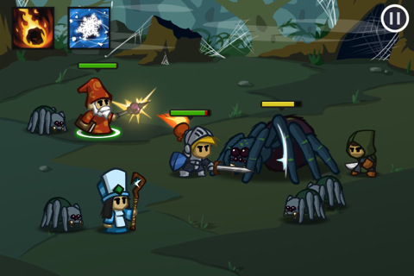

## 

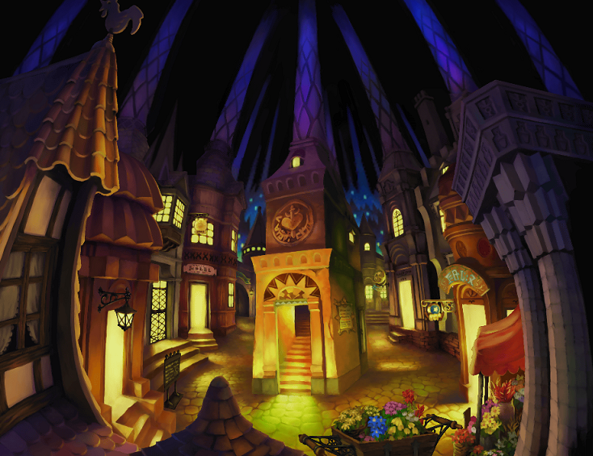

## 

## 

## 

## 

## 

## 

## 

## 

## Battle Scenes references:

**Island**

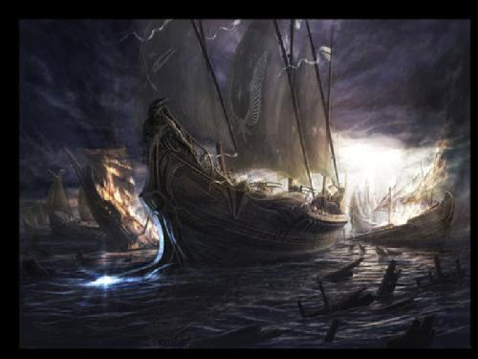

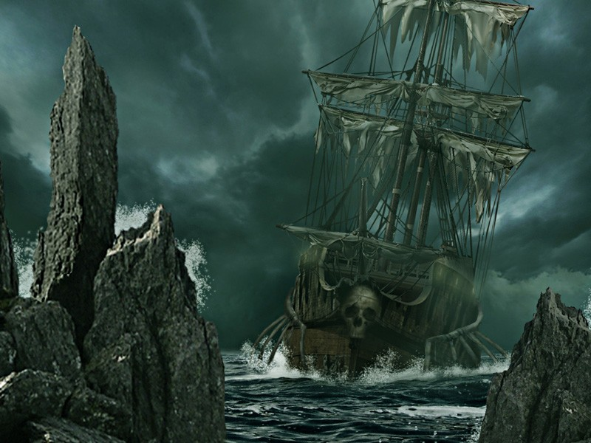

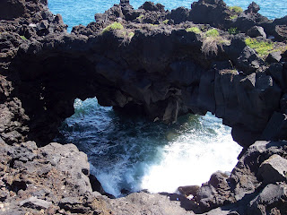

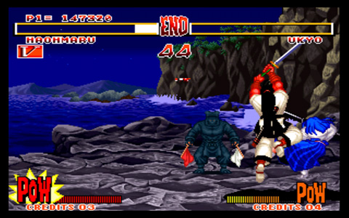

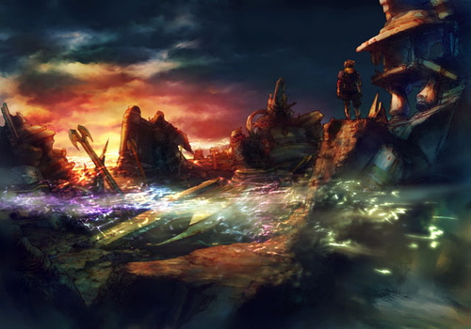

**Underworld**

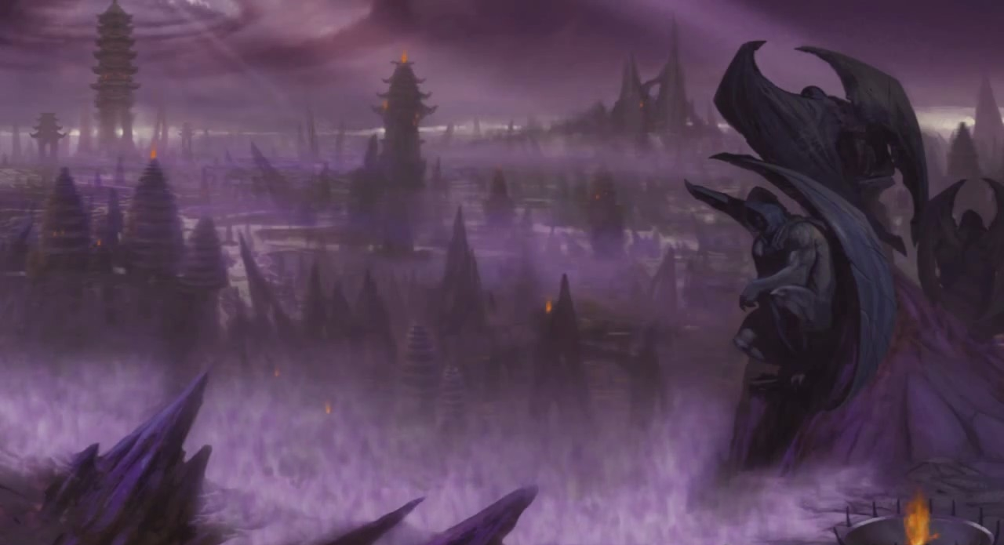

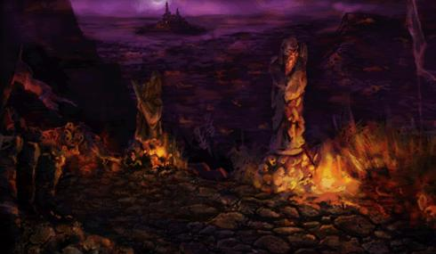

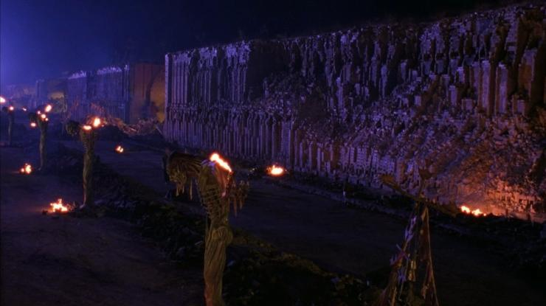

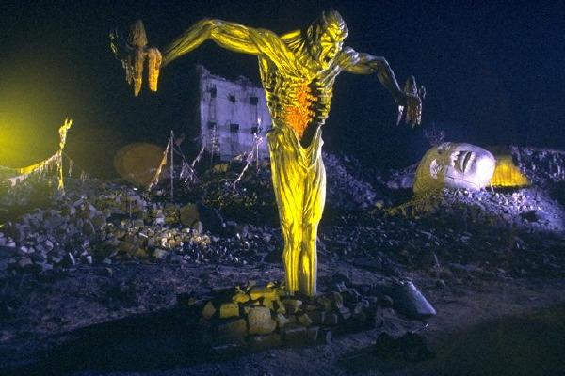

**Volcano**

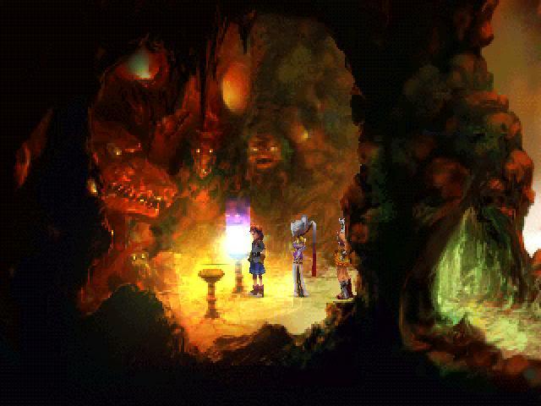

## 

## 

## 

## 

## 

## Inventory reference

## <http://www.youtube.com/watch?v=4IU_HgIU-0M>

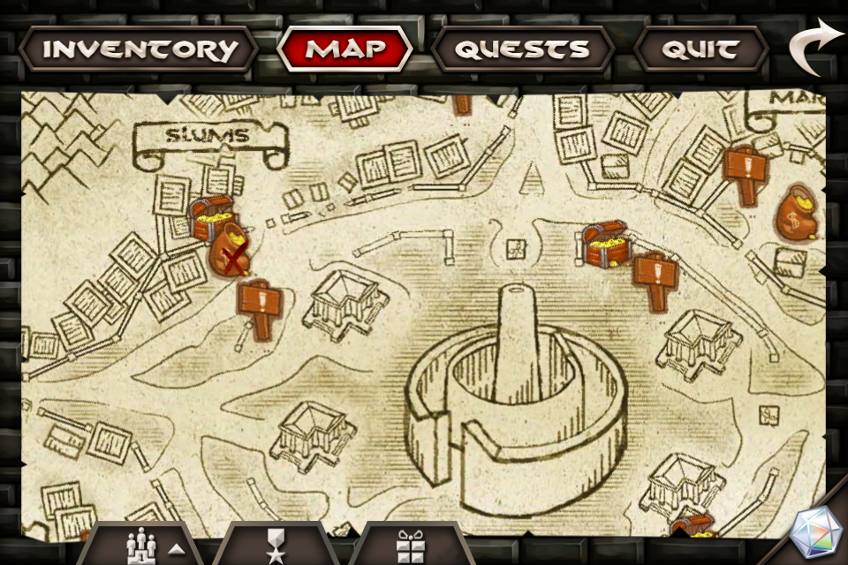

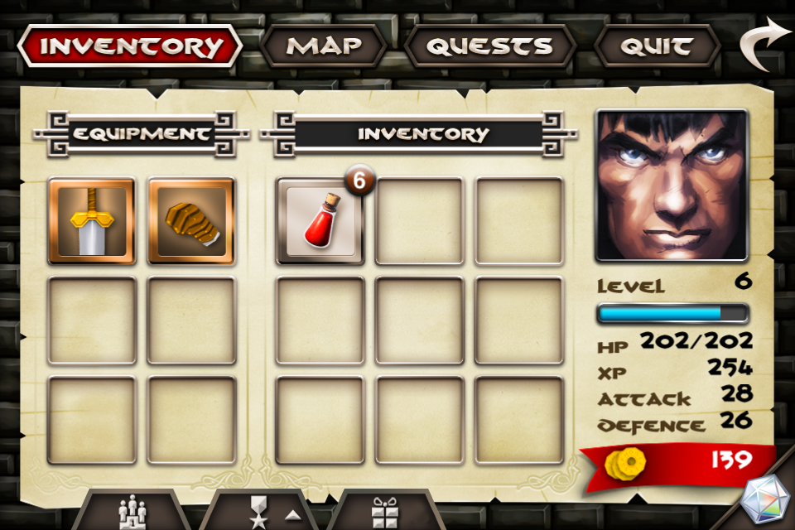

## 

## 

## 

## 

## 

## 

## 

## Enemy References:

**Executioner**

## 

## 

## 

## 

## 

## 

## 

## 

## Impaled



 

 

 

 

 